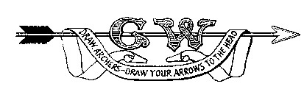 Grand Western Archery Society Request form for coaching course funding
(Please use one application form per candidate)
Course details
Number | Organiser |  | Venue |  | Cost £ |  | Completion date
Child protection course
Course provider | Cost £
Candidate details
Name | AGB number | Address |  |  | Email |  |  | Phone
Sponsorship
Name | Position | Phone |  |  | Financial support £ |  |  | Signature
Club
Name | Position | Phone |  |  | Financial Support £ |  |  | Signature
County
Name | Position | Phone |  |  | Financial Support £ |  |  | Signature
Region
Name | Position | Phone |  |  | Financial Support £ |  |  | Signature
Payment details (Cheque OR BACS)
Cheque payable  to:  (mark x in appropriate box) | Candidate  (using candidate address) | Club  (using club name above) |  | BACS online payment (if you wish to receive payment via online banking, please  provide details below)
Cheque payable  to:  (mark x in appropriate box) |  |  |  | Name |  | Account No. |  |  | Sort code
Administration details for GWAS use only
Cheque number | Date posted
Notes including reasons for rejection by Club, County or Region if appropriate

Once this form has been completed by your club (if applicable) and county, please Email to: coaching@gwas.org.uk
Post to: Lizzy Rees, Firbank, Water ST, Mere, Wiltshire, BA12 6DY

